

Course Code: CSE 232

Course Title: Numerical Analysis Laboratory

Report

ON

Numerical Integration( Trapezoidal Rule )

NN

Submitted To:

Ayesha Siddika

Assistant Professor,

City University

Department of CSE

Submission Date: 09-08-2020

Submitted By:

Name: Abidur Rahman

ID: 142362004

Batch: 36th

**ABSTRACT**

The trapezoidal rule is a numerical integration method to be used to approximate the integral or the area under a curve. The integration of [a, b] from a functional form is divided into n equal pieces, called a trapezoid.

**TABLE OF CONTENT**

|  |  |
| --- | --- |
| CONTENT | PAGE |
| Introduction | 1 |
| What is Trapezoidal Method | 2 |
| General Formula of Integration | 3 |
| How it works ? | 5 |
| History of trapezoidal method | 6 |
| Advantages | 7 |
| Application of Trapezoidal Rule | 7 |
| Problem & Solution | 7 |
| Code using octave | 8 |
| Input the value | 8 |
| Input & Output value | 9 |
| Conclusion | 9 |
| References | 9 |

**INTRODUCTION**

Numerical integration is used to obtain approximate answers for definite integrals that cannot be solved analytically. Numerical integration is a process of finding the numerical value of a definite integral.



When a function y=f(x) is not known explicitly. But we give only a set of values of the function y=f(x) corresponding to the same values of x.

Trapezoidal rule is based on the Newton-Cotes formula that if one approximates the integrand of the integral by an nth order polynomial, then the integral of the function is approximated by the integral of that nth order polynomial. Integration of polynomials is simple and is based on the calculus. Trapezoidal rule is the area under the curve for a first order polynomial (straight line).

**What is Trapezoidal Method**

In numerical analysis, the trapezoidal rule or method is a technique for approximating the definite



It also known as Trapezium rule.

The trapezoidal rule works by approximating the region under the graph of the function {\displaystyle f(x)}as a [trapezoid](https://en.wikipedia.org/wiki/Trapezoid) and calculating its area.

The trapezoidal rule may be viewed as the result obtained by averaging the [left](https://en.wikipedia.org/wiki/Riemann_sum#Left_Riemann_sum) and [right](https://en.wikipedia.org/wiki/Riemann_sum#Right_Riemann_sum) [Riemann sums](https://en.wikipedia.org/wiki/Riemann_sum), and is sometimes defined this way. The integral can be even better approximated by [partitioning the integration interval](https://en.wikipedia.org/wiki/Partition_of_an_interval), applying the trapezoidal rule to each subinterval, and summing the results. In practice, this "chained" (or "composite") trapezoidal rule is usually what is meant by "integrating with the trapezoidal rule".

The approximation becomes more accurate as the resolution of the partition increases (that is, for larger{\displaystyle N}{\displaystyle \Delta x_{k}} decreases). When the partition has a regular spacing, as is often the case, the formula can be simplified for calculation efficiency.

As discussed below, it is also possible to place error bounds on the accuracy of the value of a definite integral estimated using a trapezoidal rule.

**General Formula of Integration**

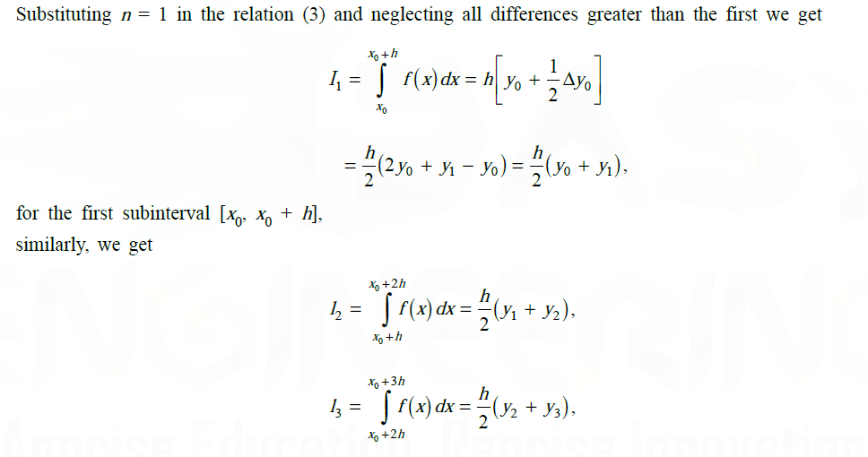

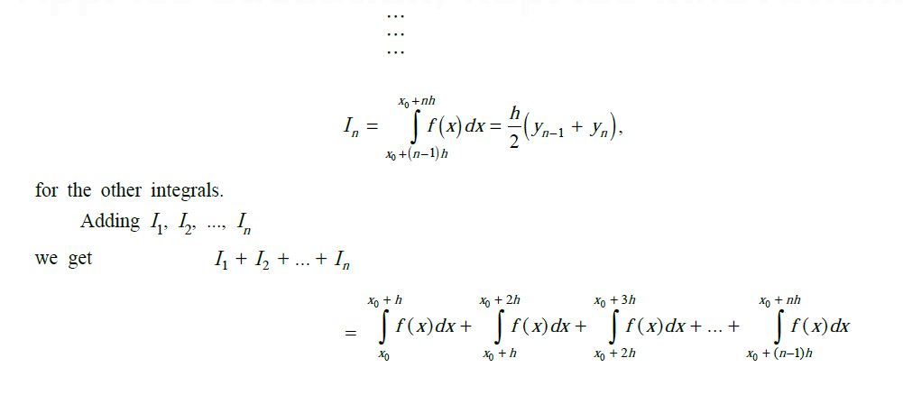

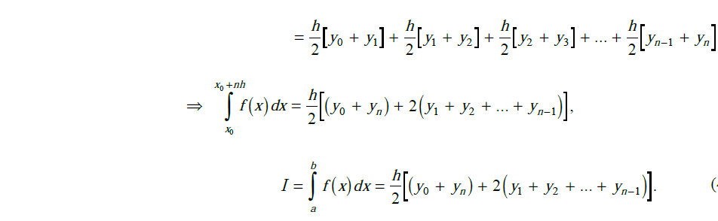

**How it works**

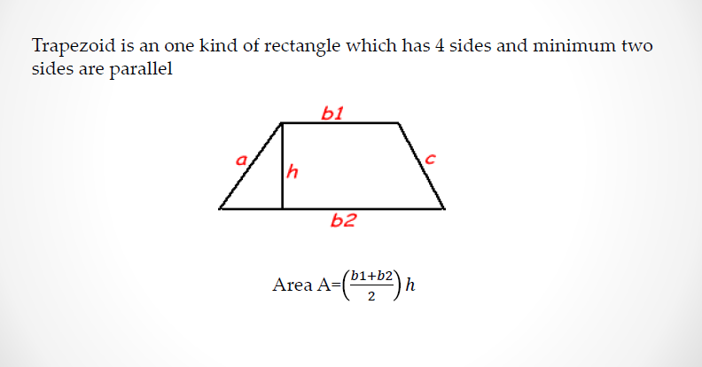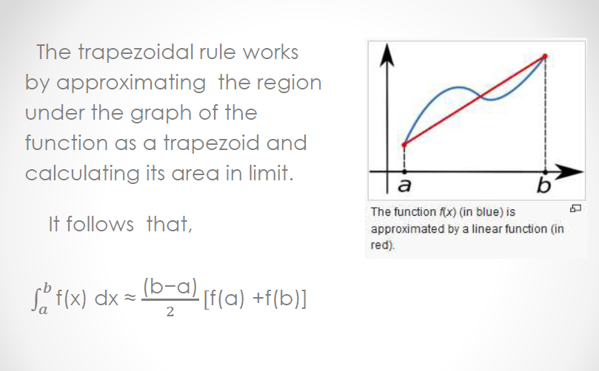

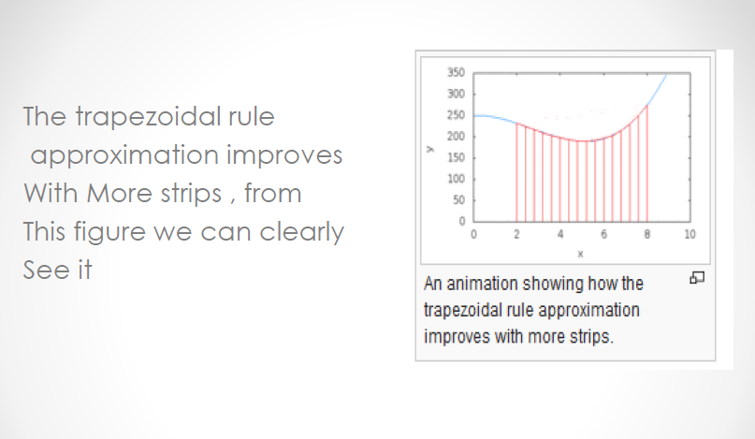

**History of trapezoidal method**



**Advantages**

There are many alternatives to the trapezoidal rule, but this method deserves attention because of

* Its ease of use
* Powerful convergence properties
* Straightforward analysis

**Application of Trapezoidal Rule**

* The trapezoidal rule is one of the family members of numerical-integration formula.
* The trapezoidal rule has faster convergence.
* Moreover, the trapezoidal rule tends to become extremely accurate than periodic functions.

**Problem & Solution**

*Problem: Find the value of $\int_{0}^{1}{\frac{dx}{1+x^{2}}}$* , *taking 5 subinterval by Trapezoidal rule, correct to five significant figures. Also compare it with its exact value.*

*Solution:*

clc

clear

a=input('Enter the value of a=');

b=input('Enter the value of b=');

n=input('Enter the value of n=');

h=(b-a)/n;

for r=1:1:10

x(1)=0;

y(1)=(1/(1+x(1)^2));

x(r+1)=x(r)+h;

y(r+1)=(1/(1+x(r+1)^2));

end

I=h/2*((y(1)+y(6))+2*(y(2)+y(3)+y(4)+y(5)));

fprintf('The integral value is %0.4f',I);

**Code using octave**

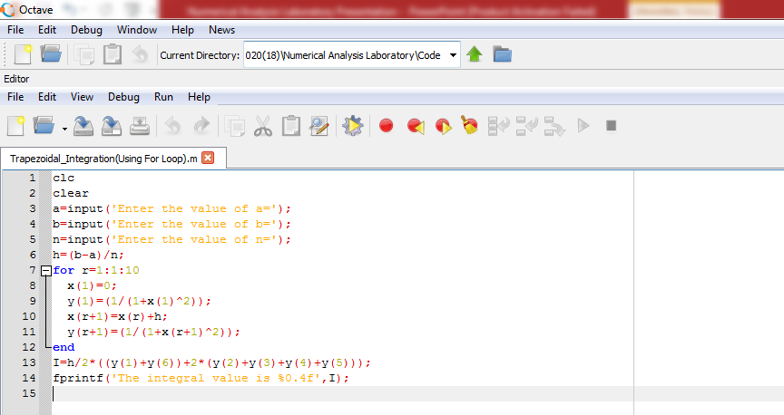

**Input the value**

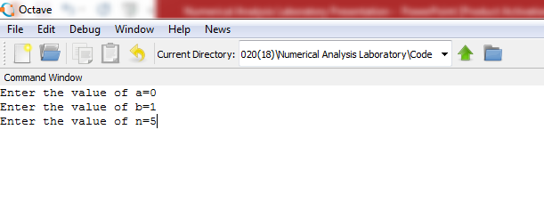

**Input & Output value**

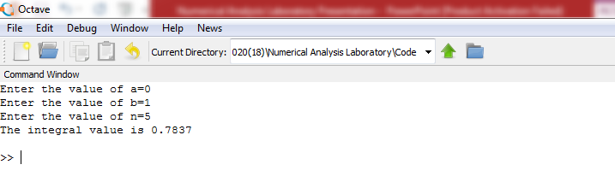

**Conclusion**

Trapezoidal Method can be applied accurately for non periodic function, also in terms of periodic integrals. when periodic functions are integrated over their periods, trapezoidal looks for extremely accurate.

**References**

* <http://en.wikipedia.org/wiki/Trapezoidal_rule>
* <http://blogs.siam.org/the-mathematics-andhistory-of-the-trapezoidal-rule/>
* And various relevant websites